Industry-specific intelligent fire management system

# Case of use of project

Fire alarm systems are only effective if they can generate reliable and fast fire alerts with exact location of fire. There is a direct correlation between the amount of damage caused by fire and interventions time in various fire alarm systems. As the time of intervention decreases, the damage also decreases. Hence the most important factor in a fire alarm system is the reaction or response time of fire alarm system, that is, the time between fire detection and extinguishing.  
  
The earliest recorded examples of fire protection can be traced back to the Roman Empire and the catastrophic fires that started in Rome. As a result, Emperor Neron has adopted regulations that required fireproof material for walls and buildings restoration to be used. The second recorded case of adopting fire protection regulations occurred in the year 1666, after the Great fire of London, which destroyed more than 80% of the city. The fire of London spurred interest in the development of the first equipment for fire suppression in the form of hand pumps and fire hydrant installation for water supply.

Progression of Fire Detection Devices

The first generation of fire detection devices (1849-1940) was based on thermal detectors. But the start of fire alarm systems development began with the invention of the telegraph by Samuel F. B. Morse in 1844. The first practical fire detection systems using telegraph, was developed in U. S. by Dr. William Channing and Moses G. Farmer in 1852. Two years later, he applied for a patent for his electromagnetic telegraph fire protection system intended to be used in cities. In Europe in 1848 the first fire alarm device was developed by C.A. von Steingel, which was operated by the firemen and used button switches and different kinds of bells to give prearranged audio signals. The first telegraph device was created three years later in Berlin and as fire alarm telegraph equipment, used a cable connection, to alert total of 37 fire stations. The development of the first temperature sensors started with the introduction of bimetallic sensors in the 19th century. The working principle of these sensors was based on the unequal expansion between the two metal stripes. These relays were reliable and durable, and are still considered ideal for many industrial applications.

Smoke Detectors: Fire smoke detectors are most critical and front end component of any fire detection & alarm system. These front end sensors have also evolved over the time and its’ their advancement which has contributed in making conventional fire alarm System, intelligent & smart-because without these smart, fast, reliable and addressable front line sensors, no fire alarm system could have been made smart or intelligent. The evolution of these frontline sensors can be divided into four generations based on their developments, improvement, and merging with the electronic technology industry.

The first generation of smoke detectors started in 1930 when first electronic smoke detector was actually made by Swiss physicist named Walter Jaegerleading to the invention of the first electronic device for smoke detection. Later he developed the first patented smoke detector in the early 1940s.

The second generation of smoke detectors was developed between early 1960s until 1975, where americium 24, a radioactive source for ionization, was used for application in the electronics industry.

In 1964 an ionization smoke detector with a 24V power supply was developed by Alert. However these detectors were to be made in accordance to international rules, and also were needed to have an appropriate radioactivity label for their functioning. After detectors are used, they were to be properly disposed as a radioactive waste.

A year after the discovery of ionizing smoke detectors, Duane Pearsall has developed a photoelectric smoke detector. Major changes in smoke detectors technology occurred during the 70s and 80s in last century.These photoelectric smoke detectors operate on the light beam interruption principle, having a light source, usually white light or more often low-power laser, and a photoelectric module. A beam of light sent through the detector in normal conditions of cleanliness bypasses photocell usually at approx. 90 degrees. When smoke particles obstruct the light beam, there is a break-ray, which focused on the photo-electric cell changes the physical variables of the set limits thus triggering alarm.

The third generation of smoke detectors (1975-1990) is characterized by an increased interest in smoke detectors. In this period there were a number of keychanges in the detectors design, including the replacement of the filament as a light source with a light emitting diode and the use of silicon. With the development of electronics and integrated circuits, there is a decrease in the volume of the detector components, which directly contributes to physical size reduction of the detector, a decrease in energy consumption and an improved reliability. In 1982, first analogue addressable detectors were introduced.

The fourth generation of smoke detectors (1990-present) is characterized by the use of multiple detectors in a loop, and application of algorithms. Development of microelectronics has enabled the application of many different functions. This was particularly important for all types of detectors which, through the utilization of microelectronics, can be produced as intelligent components. In this way, some basic evaluation and decision-making functions can be integrated in the detector. In 1996 a first multi detector (temperature and smoke) was developed as a detector that uses smart “OR” and “AND” logic. Major changes in smoke detectors technology,were introduced by the development of smart detectors. Such smoke detectors provided option to regulate the alarm threshold via a central control panel.

During this time, along with optical smoke detector, flame detectors were also developed. Flame detectors are solutions for almost all applications where fire may occur due to large losses of complex equipment such as oil and gas pipelines, offshore platforms, automotive manufacturing facilities, aircrafts, ships, ammunition factories, nuclear plants, and where the risk of staff injury is high. These systems use devices that match the radiation energy &are sensitive to ember, charcoal, or actual fire of sufficient intensity to activate the detector and trigger the alarm. In order to reduce false alarms due to a possible misidentification of real alarms due to any transient conditions a 2-3 seconds delay is often included in the design these flame detectors.

Sensors: The first & second generation so the sensors were ‘Analogue’, however from 3rd and 4th generations of sensors/detectors the shift began towards solid state sensors and later to ‘Addressable’ type of intelligent systems in which a detector compares its current sensor value with the configured threshold to make the alarm decision, which is then transmitted to the panel when the sensor is interrogated.

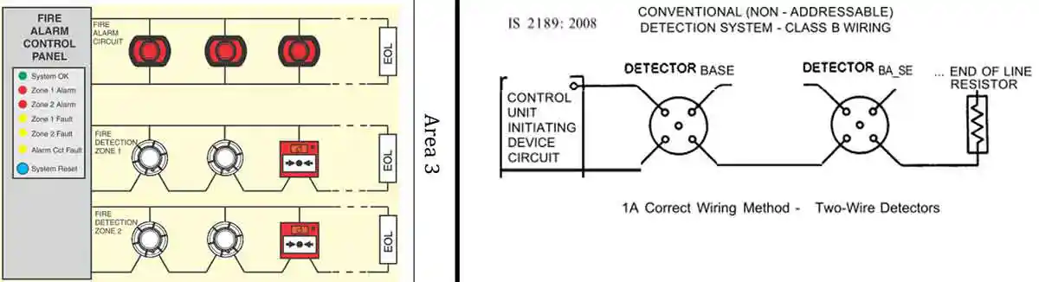

Addressable Systems

Instead of relying on changes in the electrical current running through a circuit in a conventional system, with an addressable system digital technology transfers information from the connected devices to the main control panel as binary code – combinations of ones and zeros. The alarm signal starts as an analog signal created by variations in voltage within the signalling device based on changes in the coverage. In the new age addressable devices this analogue signal is converted in to a digital or binary signal using a digital signal converter or in built processors. Depending on the device and the types of information it is designed to convey, an addressable device can transfer a wide variety of critical information to the control panel as opposed to the single triggering signal that conventional systems provide.

Because they use digital technology, addressable systems offer a much broader range in the types of information that the control panel can receive from the devices. While all addressable systems provide the location of every device on the system to the control panel, newer, “analog addressable” systems provide even more information, such as how much smoke or heat the detector is sensing. This information allows the control panel to make “intelligent” decisions such as when or when not to go into alarm mode.

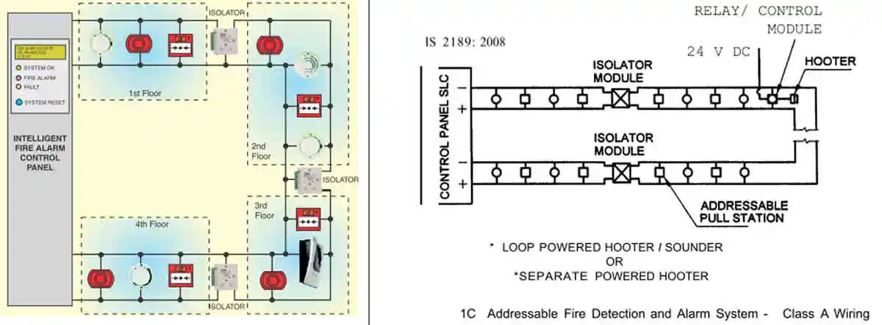

**Conventional vs. Addressable (Intelligent/Smart)**  
Conventional fire alarm systems have indeed been around a long time and have proven their reliability & credibility yet in today’s digital world, people often think of analog devices or systems as old fashioned or with out-dated technology. Many businesses today still use them with. And, while newer technologies now exist, conventional systems still remains a good option in some settings.  
  
Conventional systems are highly reliable, cost-effective, and affordable for small buildings where just one or two zones could cover the entire area. However, more and more small businesses are beginning to consider addressable systems when it comes time to replace their systems for additional benefits that the newer technology provides.  
  
The key to selecting the right one is to look beyond the initial costs when evaluating the lifetime value of the system. There are many associated factors with each type of system that may make one a better choice than the other. A closer look at some of the key differences between conventional and addressable systems can be summarised as below:

Research publications

Fire, explosion and toxic release are the three major hazards in the process industry, while fire is the most common one (Khan and Abbasi, 1999, Ricci et al., 2021). As NFPA reported (Campbell, 2018), an average of 37,910 fires occur at industrial or manufacturing properties every year in the United States. Electrical issue is the leading cause of fires, accounting for 24%. It usually occurs with exposed wiring, overloaded cables and extension cords. The majority of fire accidents involving the electrical wires and cables have been reported (Pan et al., 2021, Piccinini et al., 2009, Ye et al., 2021). Evidently, the electrical wires and cables is the main potential fire risk in industrial and manufacturing properties (Huang et al., 2021, Wang and Wang, 2020).

To reduce both the damage and injury in industrial fire accidents, timely and accurate fire detection is essential (Yuan et al., 2018). Fire detection technologies have become increasingly sophisticated, intelligent, and powerful in recent years, developing from traditional ‘point’ sensors to video-based (camera-based) technics, which could be classified into signal, image and video processing methods (Çetin et al., 2016b). However, the traditional ‘point’ sensors (smoke and heat detector) generally require sufficient high temperature or enough amount of smoke concentration to trigger the alarm, which limited its application for early detection of small fires as burning of cables (Zhang et al., 2016). During the last decades, improvements in the computing power of computers and the decreasing cost of imaging sensors made it possible to employ video-based fire detection techniques for real-time applications (Çetin et al., 2016a, Zhu et al., 2020). More recently, with the development of deep learning, AI technology has gradually emerged in the field of fire safety research. One of the most important applications is that it solves the problem of small fire detection, which is very difficult to achieve for traditional fire detection methods (Le Maoult et al., 2007, Yuan et al., 2018).

Since it is common that hundreds of cameras are installed all over large industrial buildings, fire detection by image recognition is innately suitable for industrial fire protection (Wu et al., 2019). RCNN (Region-Convolutional Neural Network) is a typical object recognition network model, and YOLO (You Only Look Once) (Redmon et al., 2016, Redmon et al., 2017) is a mature development in this family, attracting researchers to explore its potential on fire detection. From large-scale to small-scale fire detection, the YOLO model proposed by Wu et al. (2018) is good at recognizing forest fires without being affected by smoke. Shen et al. (2018) also verified the feasibility of YOLO for indoor fire detection

in buildings. However, the detection efficiency and hardware conditions remain unsolved for practical applications. Therefore, Li and Zhao (2020) proposed a new fire recognition model based on YOLO V3, reaching the demand for real-time monitoring (28 frames per second). Fang et al. (2020) also implemented an embedded device deploying YOLO, making it possible for small cameras to detect fires.

However, not only is early fire detection crucial, fire forecasting or assessment of the likely consequences is one of the most common and important steps associated with loss prevention and safety promotion in the process industry (Sarkar and Abbasi, 2006). With the help of fire development forecasting, it can provide the fire service with essential information about the fire development with some lead time and facilitate the decision-making process for the fire crew (Cowlard et al., 2010). As such, besides timely and accurate detection, analysis, and forecasting is very important. Jahn (2010) conducted a benchmark work, which proposed the simplest and fastest forecasting methodology based on the curve fitting to the available data to extrapolate previous observations forward in time. There are no physics or fundamental knowledge involved in this method. Therefore, to account for the loss of detailed information about the underlying physical processes, an improved method based on the inverse zone modeling technique in conjunction with data assimilation was investigated by many researchers (Beji et al., 2012, Jahn et al., 2011, Verstockt et al., 2013). The key idea is to incorporate sensor observations into the model in order to recover the lost information by the approximations and speed up computations.

In recent years, intelligent fire risk assessment has further promoted the safety level of industrial processes (Li et al., 2021). The widespread applications of machine learning in the chemical industry have confirmed the great potential of AI to reduce the cost of labor-intensive work (Jiao et al., 2020). This provides the excellent pattern for relieve the tedious work of monitoring and analysis artificially in industrial fire management. So, the in-depth practice of the application of machine learning in fire, the forecasting of fire evolution, is receiving extensive attention in recent years (Dey et al., 2021, Kumari et al., 2021). For example, Su et al. (2021) established a CNN model (Convolutional Neural Network) to deduce the smoke layer height of a compartment fire through inputting the fire source size, ventilation speed and ignition time. Wang et al. (2022) also implemented a CNN model for predicting HRR of compartment fires from pure smoke image (outputted from 2D-slice). However, all these inputs are impossible to be obtained in real fires actually. The researchers began to consider other available fire parameters as inputs. Wu et al. (2022a) established an LSTM model (Long Short-Term Memory) (Hochreiter, Schmidhuber, 1997) to predict the fire location, HRR and air velocity by inputting the temperature measured under the building ceiling. Following previous research, Wu et al. (2022b) continued to improved LSTM by integrating TCNN (Transposed Convolution Neural Network), achieving the forecasting of temperature distribution of buildings. With the increasing number of AI forecasting models applied to fire safety, Guo et al. (2022) studied the forecasting accuracy of HRR by comparing four machine learning methods of SVR (Support Vector Regression) (Han et al., 2021), RF (Random Forests) (Yu et al., 2022), MLP (Multilayer Perceptron) (Mamudu et al., 2021) and LSTM (Lyu et al., 2020), confirming that LSTM has the highest performance. But successful fire protection work consists of early detection, well analysis and good decision-making. Each step is closely related to each other as a whole. Whether fire detection, analysis and forecasting exist the integration possibility will help firefighting work to be more intelligent, instead of the traditional ‘blind’ firefighting work (They strongly rely on experience and intuition of the firefighters).

In the work presented here, we focus on exploring the possibility of combining the both, instead of pure fire detection or fire forecasting as aforementioned. The key idea of the paper is to use the AI recognition feature to recognize the flame (fire detection) and obtain the key fire developing characteristics from detection results (fire analysis), and then realize the prediction of this information (fire forecasting). Therefore, the current paper is focusing more on the industrial application rather than delve into the model tuning/optimization. By undertaking the cable fire experiments, the YOLO network is proposed to detect fire through the image recognition. These recognition results can be quantified into the key fire developing characteristics through conversions: the fire scale (the flame width), the speed

**Section snippets**

Work process

Fig. 1 shows the entire work process, which is divided into three parts. The first part is to obtain real-time fire images from a reasonably designed fire experiment and then provide a dataset for YOLO. The second part is the process of suppling these real-time image data to YOLO frame by frame for training. As shown in Fig. 2, the fire recognition output by YOLO contains the fire location information by labeled anchor boxes representing coordinate information in the image. Through the ratio

Design

(1)

Experimental setup

The samples of YOLO V5 are obtained from the cable fire experiments, the experimental setup is shown in Fig. 5(a). The ZR-YJV cables are installed on the double-layer cable tray model (1.5 m \* 0.7 m \*1.3 m). A high-definition camera (Sony FDR-AX100E) is arranged in 1 m in front of the tray for collecting the image at 60 frames per second. The camera height is level with the cable height and is transmitted to YOLO V5 in real-time for recognition, and then the fire spreading

Model evaluation criteria

Regardless of the extraction or the forecasting, we all hope that it is close to the benchmark. Therefore, this paper introduces the mean relative error (MRE) to evaluate the performance of two networks, as shown in Eq. (1).MRE=1N∑Dnetwork−DbenchmarkDbenchmark×100%where Dnetwork is the data from networks; Dbenchmark is the benchmark data; N is the number of data.

Training metrics

The training metrics of YOLO is shown in Fig. 7. YOLO recognizes two flames (two classes, equal to two recognition targets in Fig. 2):

Conclusions

Fire detection and forecasting are essential for industrial fire management. Real-time information on fire, such as fire burning areas and fire spread speed, can provide a reliable reference for forecasting the development of fire accidents and their losses, thereby further guiding the fire fighting and rescue tactics. In this paper, series of cable fire experiments are conducted to examine the extraction ability based on the fire detection of YOLO and the forecasting ability of ResNet for fire

**Declaration of Competing Interest**

The authors declare that they have no known competing financial interests or personal relationships that could have appeared to influence the work reported in this paper.

**Acknowledgments**

This work was supported by National Natural Science Foundation of China (NSFC, Grant No. 52006210) and the Opening Funds of State Key Laboratory of Building Safety and Built Environment & National Engineering Research Center of Building Technology (Grant No. BSBE2021–05).

**References (44)**

* J. Zhu*et al.*

**[Experimental research on natural gas leakage underwater and burning flame on](https://www.sciencedirect.com/science/article/pii/S0957582019324279" \t "_self)**